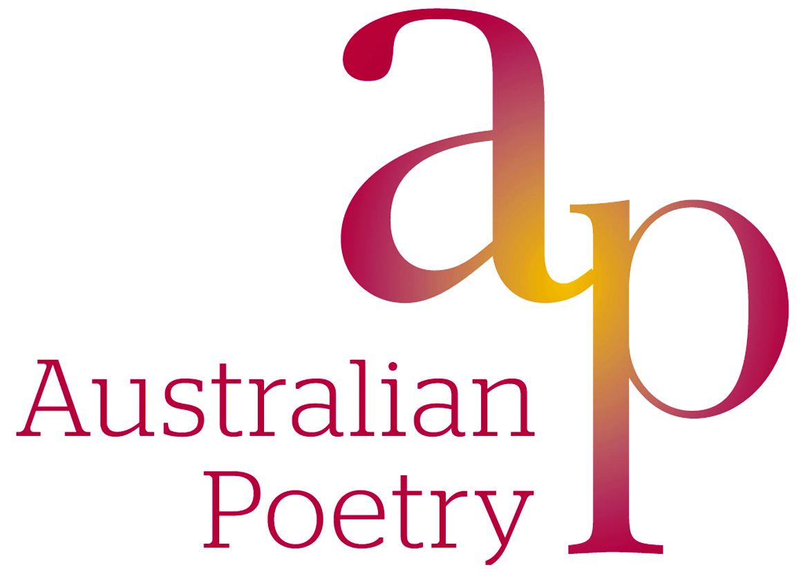

The Scanlon Prize 2014
For Indigenous Poetry

Submissions Now Open

Submissions are now being sought from poets or publishers for collections published between 1 August 2012 and 1 June 2014, for the 2014 Scanlon Prize.

The Scanlon Prize is awarded to a poet for the best single-author collection of Aboriginal poetry published in the last two years. The award includes a prize of $2000.

It is the only prize devoted specifically to books of Indigenous poetry, its purpose being to encourage the work of Indigenous poets, and to make their poetry more widely known and appreciated.

Entries may be made by poets or by publishers. Multiple entries are accepted. There is no entry form. Entrants should include a covering letter giving all contact details, and send two copies each of book being entered. Entries should be forwarded by 30 May 2014 to:

The Scanlon Award for Indigenous Poetry,
c/o Australian Poetry Ltd,
PO Box 21082, Little Lonsdale St, Melbourne VIC 8011.

The winner will be announced at an event to be held as part of the Melbourne Writers Festival and the results published on the Australian Poetry website.
Further information may be obtained from Australian Poetry Ltd by email to admin@australianpoetry.org

The Scanlon Prize is managed by Australian Poetry in collaboration with the First Nations Aboriginal Writers Network and made possible by the generosity of the Scanlon Foundation.

Background to the Scanlon Prize

The prize was initiated by the NSW Poets Union and first presented in 2004, to coincide with the Ngara Festival, the Australian Poetry Festival which focused on Indigenous issues. It has since been awarded every two years (except in 2006 it was postponed until 2007). Previous recipients include:

2004 – Alexander ‘Sandy’ Brown, Ngarla Songs, FACP, in association with Wangka Maya Pilbara Aboriginal Language Centre, Fremantle, 2003; Judge John Muk Muk Burke.

2007 – Anita Heiss, I’m not racist, but…, Salt Publishing, Cambridge, 2007; Judge Elizabeth Hodgson.

2008 – Yvette Holt, Anonymous Premonition, (UQP 2008); Judge Tara June Winch.

2010 – Jeanine Leane, Dark Secrets, PressPress, 2010; Judge Yvette Holt

2012 - Lionel Fogarty, Connection Requital, Vagabond Press 2010 ; Judge Terry Whitebeach

